Application Number | 07/2018/2742/VAR
Address | Oakland Farm  Hollins Lane  Leyland  Preston  Lancashire  PR26 8LJ
Applicant | Mr Lewis Buller

Development | Application for the variation of condition 2 (Restriction of repair and storage) of planning permission 07/2017/2505/FUL - use of polytunnel 3 for general storage (B8)
Officer Recommendation  Officer Name | Refusal  Mrs Janice Crook

Date application valid | 28.04.2018
Target Determination Date | 23.06.2018
Extension of Time | 20.07.2018
Location Plan

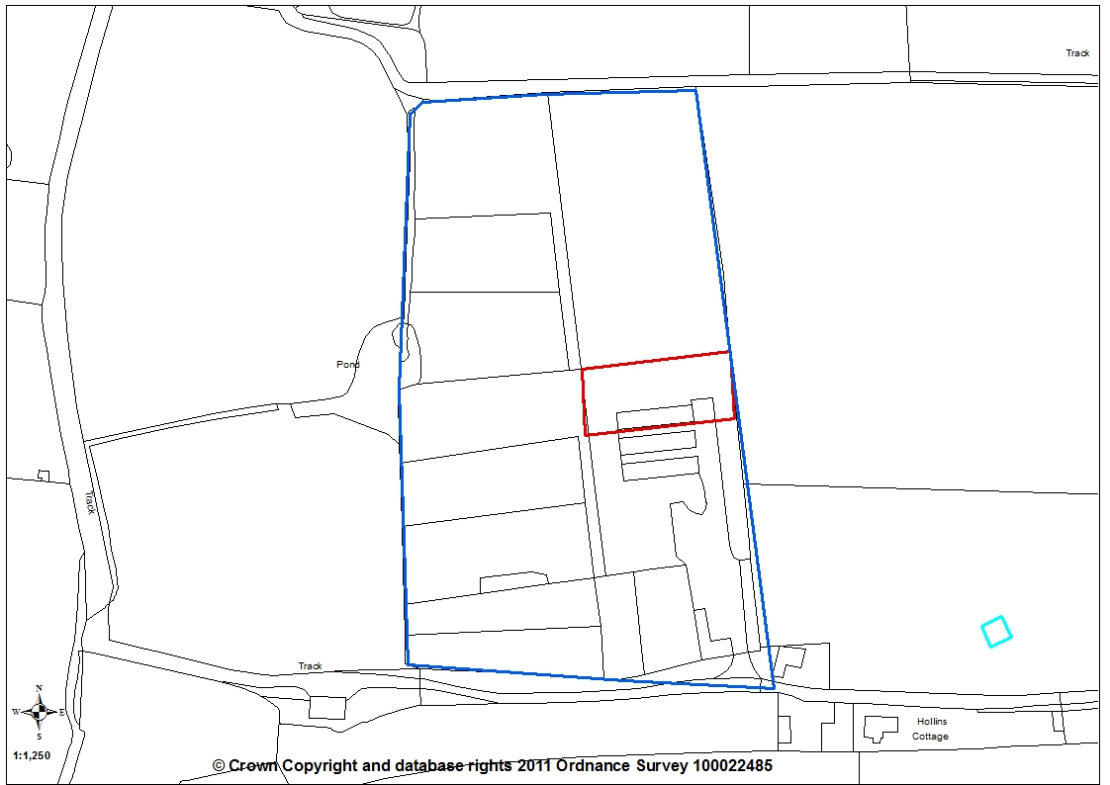

- Report Summary

  - The application is to be determined by planning committee as the applicant is related to a serving officer of the Council. The application seeks the variation of condition 2 of planning approval 07/2017/2505/FUL in respect of the use of polytunnel 3 on the Oaklands Farm site on Hollins Lane, Leyland. The condition restricts the use of the polytunnel to agricultural storage only and the applicant wishes to change this to allow general storage.

- Site And Surrounding Area

  - The application relates to the Oakland Farm site located on the north side of Hollins Lane on the outskirts of Leyland close to the Borough boundary with Chorley. The site currently consists of a stable block containing 8 stalls, a second stable/hay store which is an ‘L’ shaped open fronted wooden building, a sand paddock, three polytunnels and associated areas of hardstanding. The site is within the Green Belt with the area characterised by open green fields. Trees and hedgerows form the southern and eastern boundaries to the application site. The site is accessed via Hollins Lane which is a single track un-made road with just a few passing places along its length.

- Planning History

- Planning application 07/1994/0423 for a building for the keeping of horses with associated storage of feed was approved on 14/09/1994.

- Planning application 07/2000/0507 for the erection of 2 polytunnels and 3 storage buildings consisting of a boiler room, packing shed and refrigeration unit was approved on 19/10/2000.

- Planning application 07/2001/0081 for two polytunnels was approved on 04/05/2001

- Planning application 07/2001/0507 for the siting of static caravan for use as an agricultural dwelling was approved on 18/10/2001.

- Application 07/2002/0732 for renewal of planning permission for the temporary siting of a static caravan for use as an agricultural dwelling was approved on 25/10/2002

- Planning application 07/2004/0929 for the extension of temporary permission granted under 07/2002/0732 for siting of a static caravan for use as an agricultural dwelling was approved on 22/10/2004.

- Application for certificate of lawfulness 07/2008/0863/CLU for the use of a static caravan as a permanent residential dwelling was refused on 23/01/2009.

- Application for certificate of existing lawful development 07/2010/0333/CLU for the use of a building converted in 2001 for residential use was withdrawn.

- Planning application 07/2011/0591/FUL for the erection of block of 12 stables following demolition of existing stables; the erection of single storey building to accommodate a tack room, feed store, horse shower and hay store following demolition of existing block; the formation of a horse exercise area and extension of existing of sand paddock; the erection of office accommodation building; the change of use of existing polytunnels for the use as storage of machinery and plant, storage of haylage, shavings and straw and breeding process; and the erection of floodlighting to sand paddock was approved with conditions on 18/1/2012.

- Planning application 07/2016/0248/FUL for the erection of a two storey, detached dwelling with a glazed link to a stables/workshop building for Blacksmiths/Equestrian use and the erection of a detached, single storey building to be used as a cattery following the demolition of existing structures was refused on 25/08/2016.

- Lawful Development Certificate application 07/2017/0019/CLU to establish that the existing use of the site as a livery stables and mixed use of polytunnels for storage, repair of vehicles and general workshop is the lawful use was refused 05/05/2017

- 07/2017/2505/FUL Retrospective application for a change of use of three agricultural polytunnels and associated hardstanding to a mixed use as a mechanic's workshop (Use Class B2) and General Storage (Class B8) was conditionally approved on 03/10/2017 with condition 2 being imposed to restrict the use of the third polytunnel for agricultural storage only.

- 07/2018/0844/FUL for the erection of 1no. two-storey dwelling with detached garage, erection of domestic stable block together with the erection of a single storey building to be used as a cattery following the demolition of existing buildings was approved on 26/4/2018. An appeal is currently pending in respect of condition 27 of this planning permission with the appellant seeking to remove the condition which required the removal of outbuildings in an area of land in the applicant’s ownership immediately to the north of the site, as follows:

“That prior to the first occupation of the new the dwelling hereby approved the outbuildings identified for removal within the section of the labelled as being 'Area returned to grass' on the approved site layout plan 'Proposed Site Plan' (reference 1545-PSP01A) shall be demolished/removed and all associated material permanently removed off site in accordance with a detail to be submitted to and be approved in writing by the Local Planning Authority.”

- Proposal

  - The application seeks a variation of condition 2 of planning approval 07/2017/2505/FUL relating to the use of polytunnel 3. Condition 2 restricted the use of polytunnel 3 to agricultural storage, stating: “Notwithstanding the provision of the Town and Country Planning (Use Classes) Order 1987 (as amended) Paragraph 3(1) or any provision equivalent to this in any statutory instrument revoking and re-enacting this Order, the use of Units 1 and 2 as indicated on the submitted supporting statement at 2.4 page 4, shall be restricted to repair and storage of vehicles and Unit 3 restricted to agricultural storage, unless the prior consent of the Local Planning Authority is obtained.”

  - The proposal seeks to vary the wording to read: “Notwithstanding the provision of the Town and Country Planning (Use Classes) Order 1987 (as amended) Paragraph 3(1) or any provision equivalent to this in any statutory instrument revoking and re-enacting this Order, the use of Units 1 and 2 as indicated on the submitted supporting statement at 2.4 page 4, shall be restricted to repair and storage of vehicles and Unit 3 restricted to general storage, unless the prior consent of the Local Planning Authority is obtained.”

- Summary of Publicity

  - Neighbouring properties were notified and a site notice was posted with one letter of representation being received, commenting:

- The plans state all the existing building will be demolished
- Question why would the applicant want an ugly polytunnel when building a large new house with separate garage, multiple stables, tack room and cattery?
- Question why repair motor vehicles in a plastic polytunnel which was designed to grow mushrooms in.
- Tunnels are visible from Leyland Lane and Hollins Lane, contrary to applicant’s statement.

- Summary of Consultations

  - No consultation was carried out.

- Policy Considerations

7.1 National Planning Policy Framework (NPPF)

- 87. As with previous Green Belt policy, inappropriate development is, by definition, harmful to the Green Belt and should not be approved except in very special circumstances.

- 88. When considering any planning application, local planning authorities should ensure that substantial weight is given to any harm to the Green Belt. ‘Very special circumstances’ will not exist unless the potential harm to the Green Belt by reason of inappropriateness, and any other harm, is clearly outweighed by other considerations.

7.2 Central Lancashire Core Strategy Policy 13: Rural Economy aims to achieve economic and social improvement for rural areas by sustaining and encouraging appropriate growth of rural businesses in a number of ways, including b) supporting rural based tourist attractions, visitor facilities, recreational uses, business and storage activities and f) supporting sensitive conversions and alternative uses of farm buildings no longer needed for agriculture but which enable farm diversification where they: (i) sustain and maintain the core farm business; (ii) do not compromise the working of the farm; and (iii) are located within or near the existing farm complex; allow limited extension and replacement of existing buildings, with a preference for commercial, tourism and live/work units.

7.3 Further guidance on the re-use of buildings in the countryside is also contained in the Rural Development Supplementary Planning Documents at Chapter I. It recognises that the re-use or adaptation of existing buildings can help reduce demands for new buildings. For a rural buildings to be appropriate for re-use, it must be permanent and substantial and should not require significant extension, rebuilding or extensive alteration to accommodate the proposal. The new use should not result in the need to provide an otherwise unnecessary replacement buildings.

7.4 South Ribble Local Plan Policy G1: Green Belt has a general presumption against inappropriate development and planning permission will not be given for the construction of new buildings unless there are very special circumstances. However, exceptions to this are buildings for agriculture and forestry; provision of appropriate facilities for outdoor sport, outdoor recreation and for cemeteries, as long as it preserves the openness of the Green Belt and does not conflict with the purposes of including land within it; the extension or alteration of a building provided that it does not result in disproportionate additions over and above the size of the original building; the replacement of a building, provided the new building is in the same use and not materially larger than the one it replaces; limited infilling in villages, and limited affordable housing for local community needs under policies set out in the Local Plan; or limited infilling or the partial or complete redevelopment of previously developed sites, whether redundant or in continuing use (excluding temporary buildings), which would not have a greater impact on the openness of the Green Belt and the purpose of including land within it than the existing development.

7.5 Policy G2: The Re-Use and Adaptation of Buildings in the Green Belt allows for the re-use of existing buildings within the Green Belt, provided that the development does not have a materially greater impact on the openness of the Green Belt and the purposes of including land in it. The policy requires that the building is of permanent and substantial construction, of sufficient size and suitable for conversion to the proposed use without the need for additions or alterations which would harm its existing form or character; would not result in an adverse impact in respect of noise, odours, emissions or traffic; and the building and site has access to a public highway available for use without creating traffic hazards and without involving significant road improvements which would have an undue environmental impact.

- Material Considerations

8.1 Background
8.2 Retrospective planning application 07/2017/2505/FUL was submitted to regularise the use of the site for the change of use of existing polytunnel buildings from an agricultural use to a mixed use of B2 and B8. The site was being used for a mix of mechanics workshop; vehicle storage and storage of the applicant’s tools and equipment. The adjacent land to the north and west is agricultural land with horse stabling to the south-east, both within the applicant’s ownership but not part of the planning application. The officer’s report described the use of the polytunnels as follows:
“Polytunnel 1 – Mechanic’s workshop for car servicing, repairs, engine and gearbox changes with no bodywork and paint spraying – operated between the hours of 07:00am to 20:00pm.

Polytunnel 2 – Storage of cars and motorbikes and occasional repairs to vehicles – operated between the hours of 07:00am to 20:00pm.

Polytunnel 3 and areas of hardstanding – Storage of carts, harness, mowers, quad bikes, machinery, vehicles, trailers, tools and equipment – hours of operation to be unrestricted as this is used by the applicant is association with the existing horse stabling use on the adjacent part of the site, not part of this planning application.”

8.3 However, during consideration of this application, it was deemed appropriate to restrict the hours of use to those outlined in the Supporting Statement for the two polytunnels with the third not being restricted due to the nature of the storage in this polytunnel which was for use by the applicant for his own personal tools and equipment used in association with the horse stabling and agricultural land which was not part of that application proposal.

8.4 It was therefore considered appropriate to imposed Condition 2 restricting the use of polytunnel 3 to agricultural storage, stating:
“Notwithstanding the provision of the Town and Country Planning (Use Classes) Order 1987 (as amended) Paragraph 3(1) or any provision equivalent to this in any statutory instrument revoking and re-enacting this Order, the use of Units 1 and 2 as indicated on the submitted supporting statement at 2.4 page 4, shall be restricted to repair and storage of vehicles and Unit 3 restricted to agricultural storage, unless the prior consent of the Local Planning Authority is obtained.”

- Application Proposal
9.1 This application seeks to vary this condition to read:
“Notwithstanding the provision of the Town and Country Planning (Use Classes) Order 1987 (as amended) Paragraph 3(1) or any provision equivalent to this in any statutory instrument revoking and re-enacting this Order, the use of Units 1 and 2 as indicated on the submitted supporting statement at 2.4 page 4, shall be restricted to repair and storage of vehicles and Unit 3 restricted to general storage, unless the prior consent of the Local Planning Authority is obtained.”

9.2 The applicant has now indicated that the agricultural use of this site has ceased and therefore there is no requirement for agricultural storage and that the polytunnel remains for storage of various items but does not specify the nature of these items.

9.3 However, this appears contrary to the details provided in the retrospective planning application 07/2017/2505/FUL for the change of use of three agricultural polytunnels and associated hardstanding to a mixed use. During consideration of that application, it was apparent that only two of the polytunnels had changed used, one as a mechanic's workshop and one as general storage of vehicles with some vehicle repair. It was judged that polytunnel 3 was used by the applicant in association with horse stabling and agricultural land maintenance with the storage in this polytunnel being identified as for carts, harness, mowers, quad bikes, machinery, vehicles, trailers, tools and equipment. This permission established that the area of land and polytunnel 3 were not considered to be part of the previously developed site where the re-development was permissible under green belt policy. It must also be noted that the adjacent land is within the applicant’s ownership and is agricultural land.

9.4 This current application would also appear to conflict with a planning permission 07/2018/0844/FUL which was approved on 26 April 2018. The permission was for the erection of a two-storey dwelling with detached garage, domestic stable block with tack room together with a single storey building to be used as a cattery following the demolition of the existing buildings on site. That application did not include the polytunnel, subject of this current application, within the red edge but it was included in the blue edge (other land within the applicant’s ownership). The approved site layout plan 1545-PSP01A clearly showed the polytunnel was to be removed and the area in which it is located return the grass. Condition 2 was included to ensure the development was carried out in accordance with that approved plan:
“The development, hereby permitted, shall be carried out in accordance with the submitted approved plans ref 'Location Plan', 1545-PSP01A (Proposed Site Plan), 1545-PR05A (Proposed Stables), 1545-PR04B (Proposed Cattery Building), 1545-PR01A (Proposed Garage Plans), 18-001 (Proposed House Plans) and 18-002 (Proposed House Elevations).”

9.5 Additionally, condition 27 was also included to ensure that the polytunnel be removed prior to first occupation of the new dwelling, as follows:
“That prior to the first occupation of the new the dwelling hereby approved the outbuildings identified for removal within the section of the labelled as being 'Area returned to grass' on the approved site layout plan 'Proposed Site Plan' (reference 1545-PSP01A) shall be demolished/removed and all associated material permanently removed off site in accordance with a detail to be submitted to and be approved in writing by the Local Planning Authority.”

9.6 In determining that application it was considered that, although the application site is located within the Green Belt, the site is lawfully in a mixed use of B2 (General Industrial), B8 (Storage and Distribution) and livery stables. The application site therefore constituted brownfield land (previously developed) with the wider parcel of land in the applicant’s ownership being wholly in an agricultural use and constituting greenfield land (not previously developed). This further established that the land and polytunnel 3 were not considered to be part of the previously developed site where re-development was permissible under green belt policy. Green Belt policy is restrictive and has a general presumption against inappropriate development unless there are very special circumstances.

9.7 It is noted that Condition 27 is now subject of an appeal in which the appellant contests that the outbuildings (polytunnel 3) should be removed and that the condition was imposed unlawfully. However, the LPA is of the opinion this condition was imposed lawfully.

9.8 The main issues for consideration when determining a planning application in the Green Belt are:
a) Whether the proposal would be inappropriate development in the Green Belt for the purposes of the NPPF (the Framework).
b) The effect of the proposal on the open ness of the Green Belt
c) If the proposal is inappropriate development whether the harm by reason of inappropriateness and any other harm, is clearly outweighed by other considerations so as to amount to the very special circumstances necessary to justify it.

a) Whether inappropriate development:

Paragraph 89 and 90 of the National Planning Policy Framework, the Framework set out those categories of development which may be regarded as not inappropriate, subject to certain circumstances. The design, construction and use of polytunnels for agriculture is considered appropriate within the Green Belt. However, the use of the polytunnel for general storage is considered as inappropriate development within the Green Belt. General Storage is not an acceptable use within the Green Belt and the use does not fall within the listed exceptions of Paragraph 89 which is replicated within Policy G1 of the South Ribble Local Plan. It is therefore considered that the proposal would represent inappropriate development, as set out in the Framework. According to Paragraph 87 of the Framework inappropriate development is, by definition harmful to the Green Belt.

b) Openness:

Openness is an essential characteristic of the Green Belt. It can be considered the absence of built or otherwise urbanizing, development. It is acknowledged that the polytunnels are acceptable development associated with agriculture. However, the use of the polytunnel for general storage together with the associated vehicular movements is considered inappropriate development within the Green Belt and therefore the use of the polytunnel would conflict with one of the purposes of the Green Belt. If the polytunnel is not required for agriculture it should be removed to preserve the openness of the Green Belt.

c) Other considerations:

Whilst the applicant has advised that the polytunnel is no longer required for agriculture, the council has not been provided with any evidence to demonstrate very special circumstances to outweigh the harm to the Green Belt and other harm that the use of the polytunnel for general storage would cause. Therefore, the proposal would be inappropriate development in the Green Belt which is by definition harmful.

- Conclusions
10.1 Polytunnel 3 was established as being for the storage for the applicant’s own tools and equipment for a use associated with horse stabling and maintenance of agricultural land with the previous permission 07/2017/2505/FUL. At that time it was not accepted that polytunnel 3 could be used for general storage as was the case with the two other polytunnels. There was a clear case that the use of the other two polytunnels had been used for the maintenance and storage of motor vehicles but not for the third polytunnel. The associated land remained in agricultural use and the polytunnel together with the area in which it is located was not considered to be part of the previously developed site. Therefore, if the agricultural use of the area has indeed ceased as the applicant now states, it does not automatically follow that the use of the polytunnel for general storage is an acceptable one given that it is within the Green Belt where such uses are considered inappropriate. Although among the exceptions to Green Belt development are buildings for agriculture and forestry which allowed for the polytunnels construction initially, in the case of polytunnel 3 no ‘very special circumstances’ have been demonstrated to allow the change of use from agricultural storage to a B8 general storage. The items stored in the building are considered to be of an agricultural/horsicultural nature.

10.2 In seeking the amendment to the wording of condition 2 to allow the use of polytunnel 3 for general storage (B8), it is considered this would have a detrimental impact on the Green Belt in which it is located. The proposal would result in this part of the site then constituting previously developed land, which would conflict with Green Belt policy in terms of inappropriate development. It is considered that the proposed development therefore constitutes inappropriate development in the Green Belt resulting in definitional harm to the openness of the Green Belt. No ‘very special circumstances’ have been provided to allow the change of use of this third polytunnel and the details that have been provided are more of a general nature with the planning statement only stating: “The agricultural use of this site has ceased and as such the applicant seeks to remove the agricultural storage condition. The poly tunnel will still be used for storage of various items and not for any other use.”

10.3 It is considered that the use of this part of the site and the land to which it is associated should remain in agricultural use. The proposed change to the wording of the condition and therefore the use of the polytunnel would conflict with Green Belt policy, amounting to inappropriate development with no very special circumstances being put forward as to why the use of the polytunnel should change from an agricultural use to a general storage use. As no ‘very special circumstances’ have been provided by the applicant which clearly outweigh the harm that would be caused to the Green Belt by reason of inappropriateness and no such circumstances are considered to exist, the proposal is considered contrary to the requirements of paragraphs 87-88 of the NPPF and Policy G1 of the South Ribble Local Plan

10.4 Furthermore, the proposal would also conflict with the later planning permission 07/2018/0844/FUL which required polytunnel 3 to be removed and the site returned to green field within the green belt.

10.5 Therefore it is considered the proposal to vary condition 2 to allow for general storage cannot be justified in this green belt location and the application is recommended for refusal with condition 2 remaining as originally worded.

- RECOMMENDATION:

11.1 Refusal.

- REASONS FOR REFUSAL:

12.1 The use of polytunnel 3 was restricted by the previous planning permission 07/2017/2505/FUL to agricultural storage only. The proposal to allow for general storage would amount to inappropriate development in the Green Belt with no very special circumstances being put forward to allow for the inappropriate development. As no ‘very special circumstances’ have been provided by the applicant which clearly outweigh the harm that would be caused to the Green Belt by reason of inappropriateness and no such circumstances are considered to exist, the proposal is considered contrary to the requirements of paragraphs 87-88 of the National Planning Policy Framework (NPPF) and Policy G1 of the South Ribble Local Plan

12.2 Additionally, it is considered that the proposal would conflict with planning permission 07/2018/0844/FUL which requires polytunnel 3 to be removed and the site returned to green field within the green belt. However, it is acknowledged that the applicant may choose not to implement this extant permission and therefore this application to vary condition 2 of planning permission 07/2017/2505/FUL has been considered in terms of its impact on the Green Belt.

- RELEVANT POLICY

National Planning Policy Framework (NPPF)
G1 Green Belt
G2 The Re-use and Adaptation of Buildings in the Green Belt

